About the module: Key points for students
Word
You are encouraged to explore the features of the word processor you are using but to get started there here a few useful features.
The ribbon
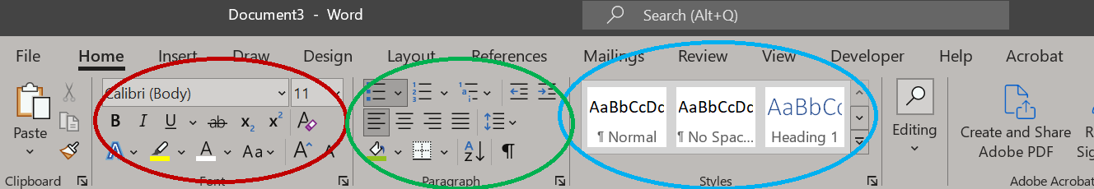
Features that select:
the font and size
set text to Bold, Italics, Underlined etc.
Features to select:
text effects
highlighting text
text colour
alignment, left, centre, right or full etc.
A range of formatting options such as titles and headings.

The ‘Design’ tab provides a range of page designs you might find useful.
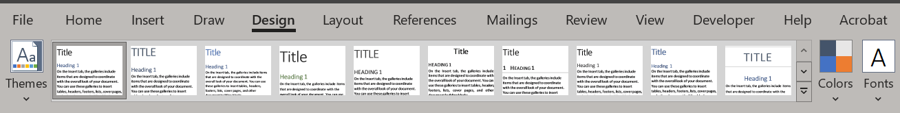
The ‘Insert’ and ‘Shapes’ tabs allow you to include a range of vector graphics.
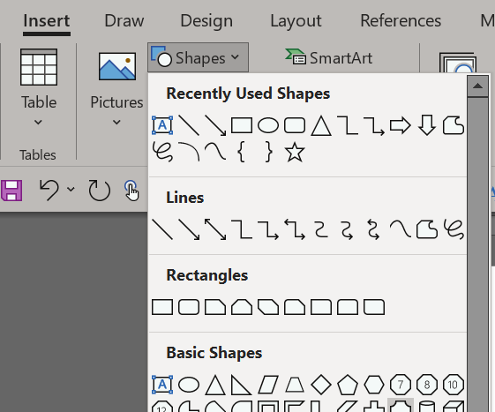
PowerPoint
To get started create a new presentation by choosing a blank presentation or one of the other themes.
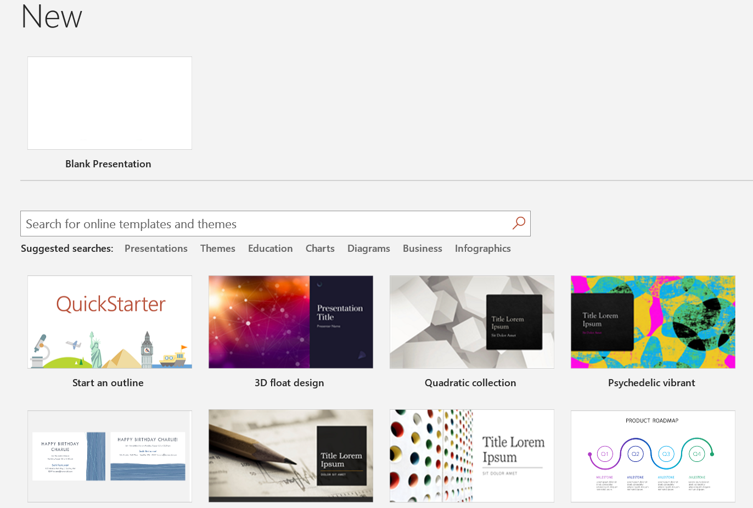
You can start editing by adding text and images to a blank slide.
To add another slide, select the new slide option. You can select a new blank slide or a different layout from those available.
Inserting shapes is the same as in Word.
The Transitions tab allows you to select how a slide will transition to the next one.
To view the presentation click on the Slide Show tab. You can play from the start, from the current slide or use one of the many other options.
